Monday, 14 September 2026, postcard

Château Cormatin, Romanesque church at Chapaize, afternoon cruising

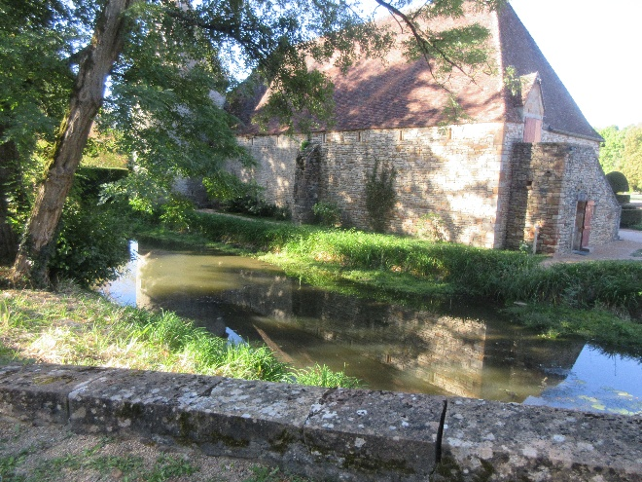
Beaune, the capital of the Burgundy wine region, was the northernmost point on our cruise up the Sâone. On Monday, we motored back south to tour Château Cormatin, between Tournus and Cluny. Three friends and business partners were looking for a summer place, so they chipped in and bought an abandoned (well, long unoccupied) château and set about restoring it. That was 30 or 40 years ago, and now they live there full time. They don't seem to produce or sell wine, but they open parts of the house to visitors to help subsidize the upkeep. The three actually own a second château, but they plan to sell it—keeping up two at once proved too much.
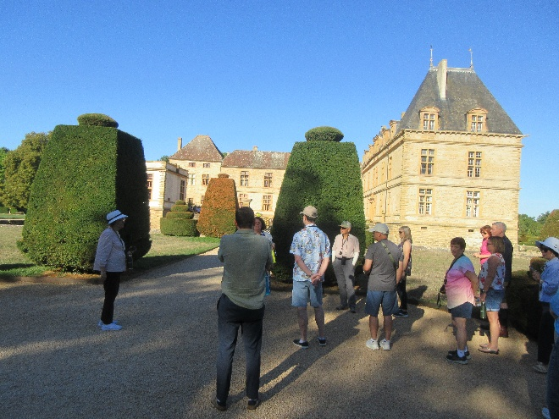
One of the owners came out to open the gates for us, next to this picturesque little stream and one of the château's outlying barns.

We entered the central courtyard by crossing a wooden bridge over the moat. Our guide explained that the rooms we visited were furnished with furniture original to the period but not to the house itself—all its furniture was lost one way or another while it was disused.

To the right of the main building is the formal "French" garden and to the left of it a gorgeous vegetable, fruit, and cut-flower garden.

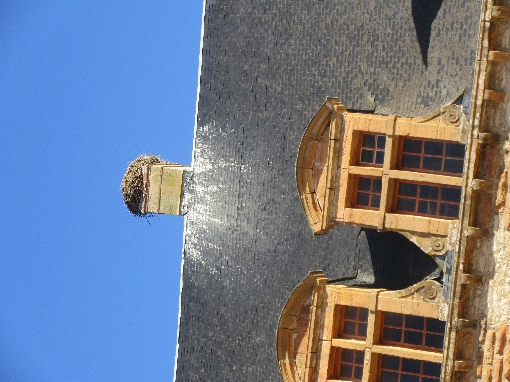
One of the chimneys on the right-hand wing of the house was topped by a huge stork's nest, but the storks were not in evidence while we were there.

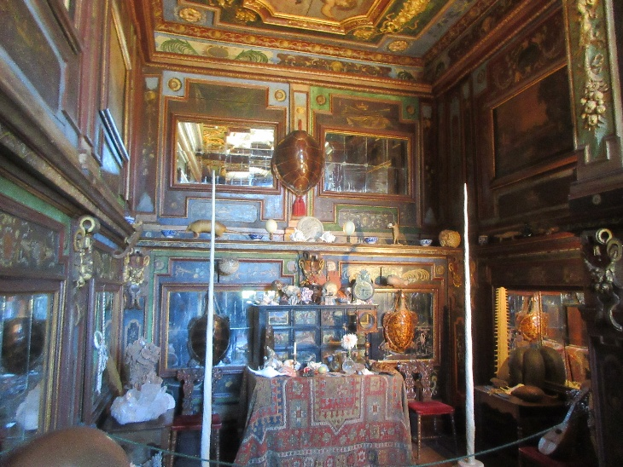
The restoration centered on an early occupant of the castle and his 15-year-old bride. My favorite rooms were the cabinet of curiosities
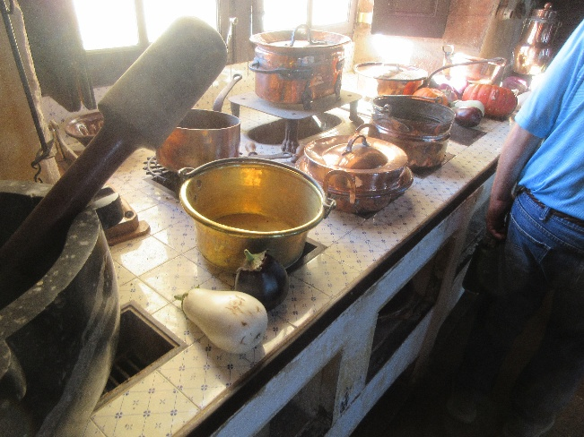
and the magnificent old kitchen.
The decorative fruits and vegetables are, for once, real.

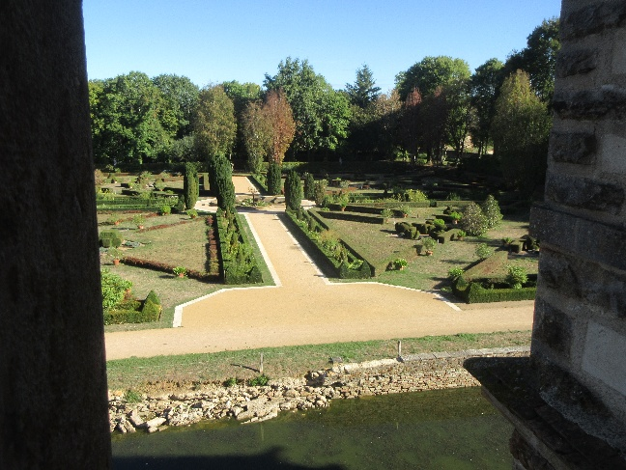
Here's a view of part of the formal garden, which was actually gasping for water. The moat was also very low; the drought has been extreme, and water restrictions are severe.
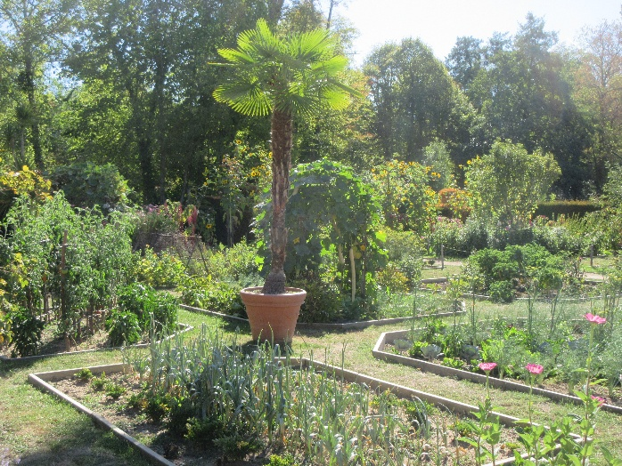

The kitchen garden, on the other hand, was in fine shape. Maybe the restrictions don't apply to food plants.

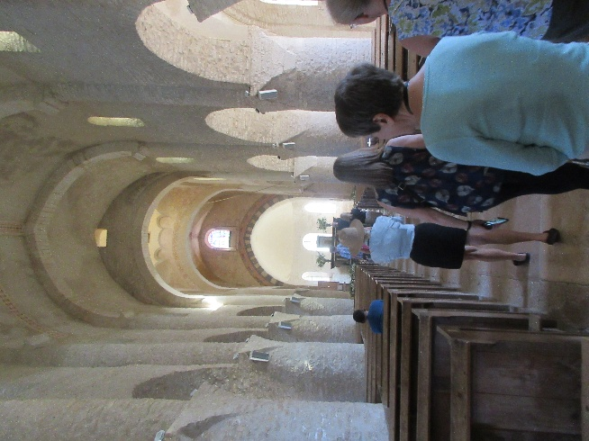
On the way back to the ship, we stopped in Chapaize to look at the lovely little Romanesque church of St. Martin.

Back on the ship, dinner was preceded by a French "apero"—a currently popular style of party featuring cocktail munchies. You invite friends over for wine and a wide array of heavy hors d'oeuvres, trending heavily towards charcuterie and cheeses. In addition, we got crispy panko-crusted frogs' legs and buttery-garlicky snails.

